# **Name: Abdurrahman Qureshi**

# **Roll No: 242466**

Practical No: 6

Date Of Performance: 19/09/2025

Aim: ` To demonstrate the end-to-end configuration and execution of a Scrum framework within a project management tool.

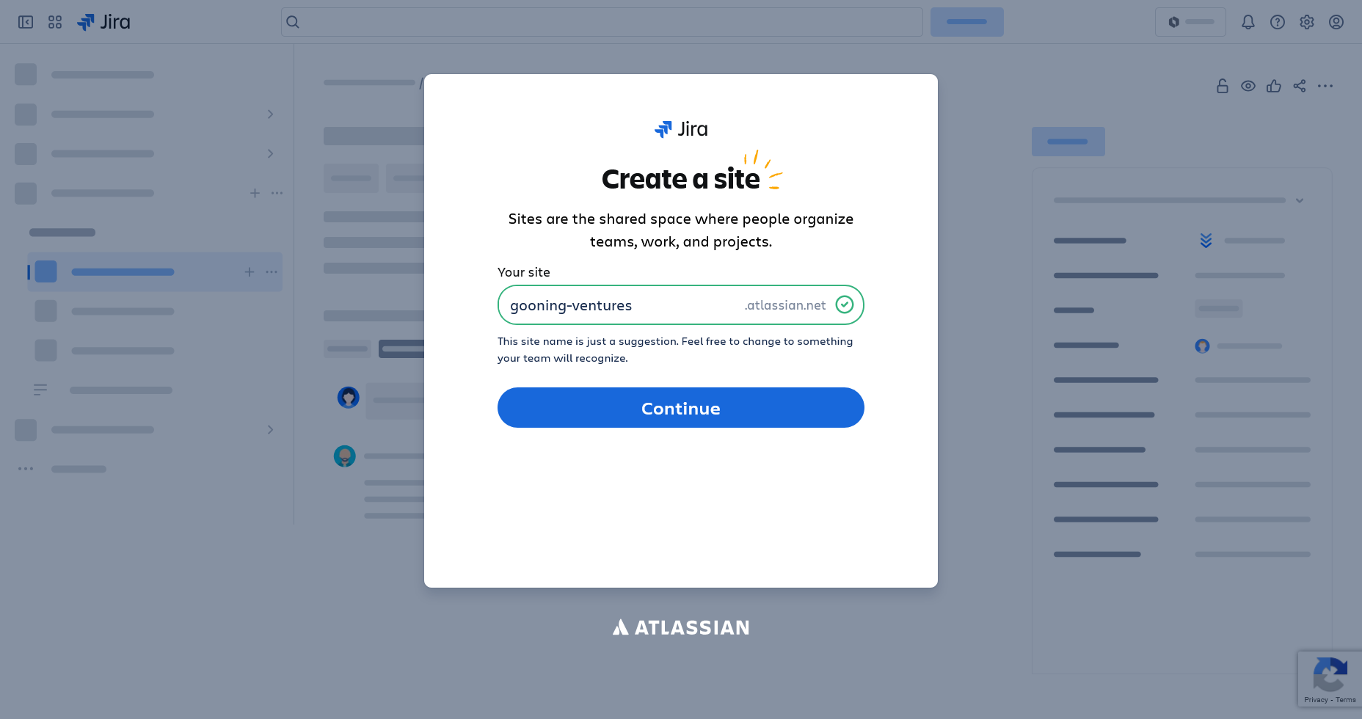

Setting up a site

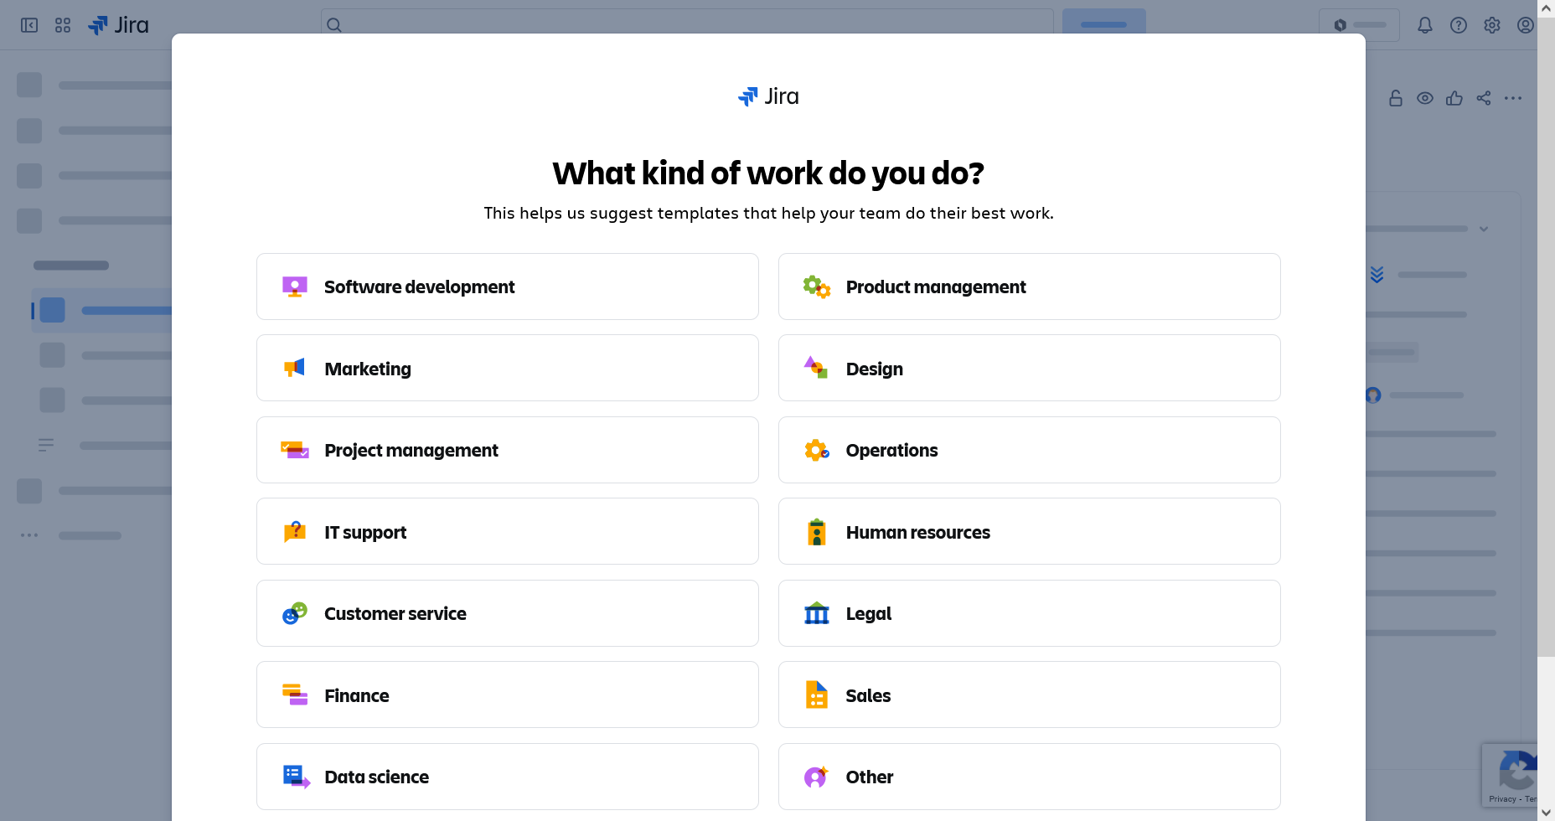

Choosing type of work

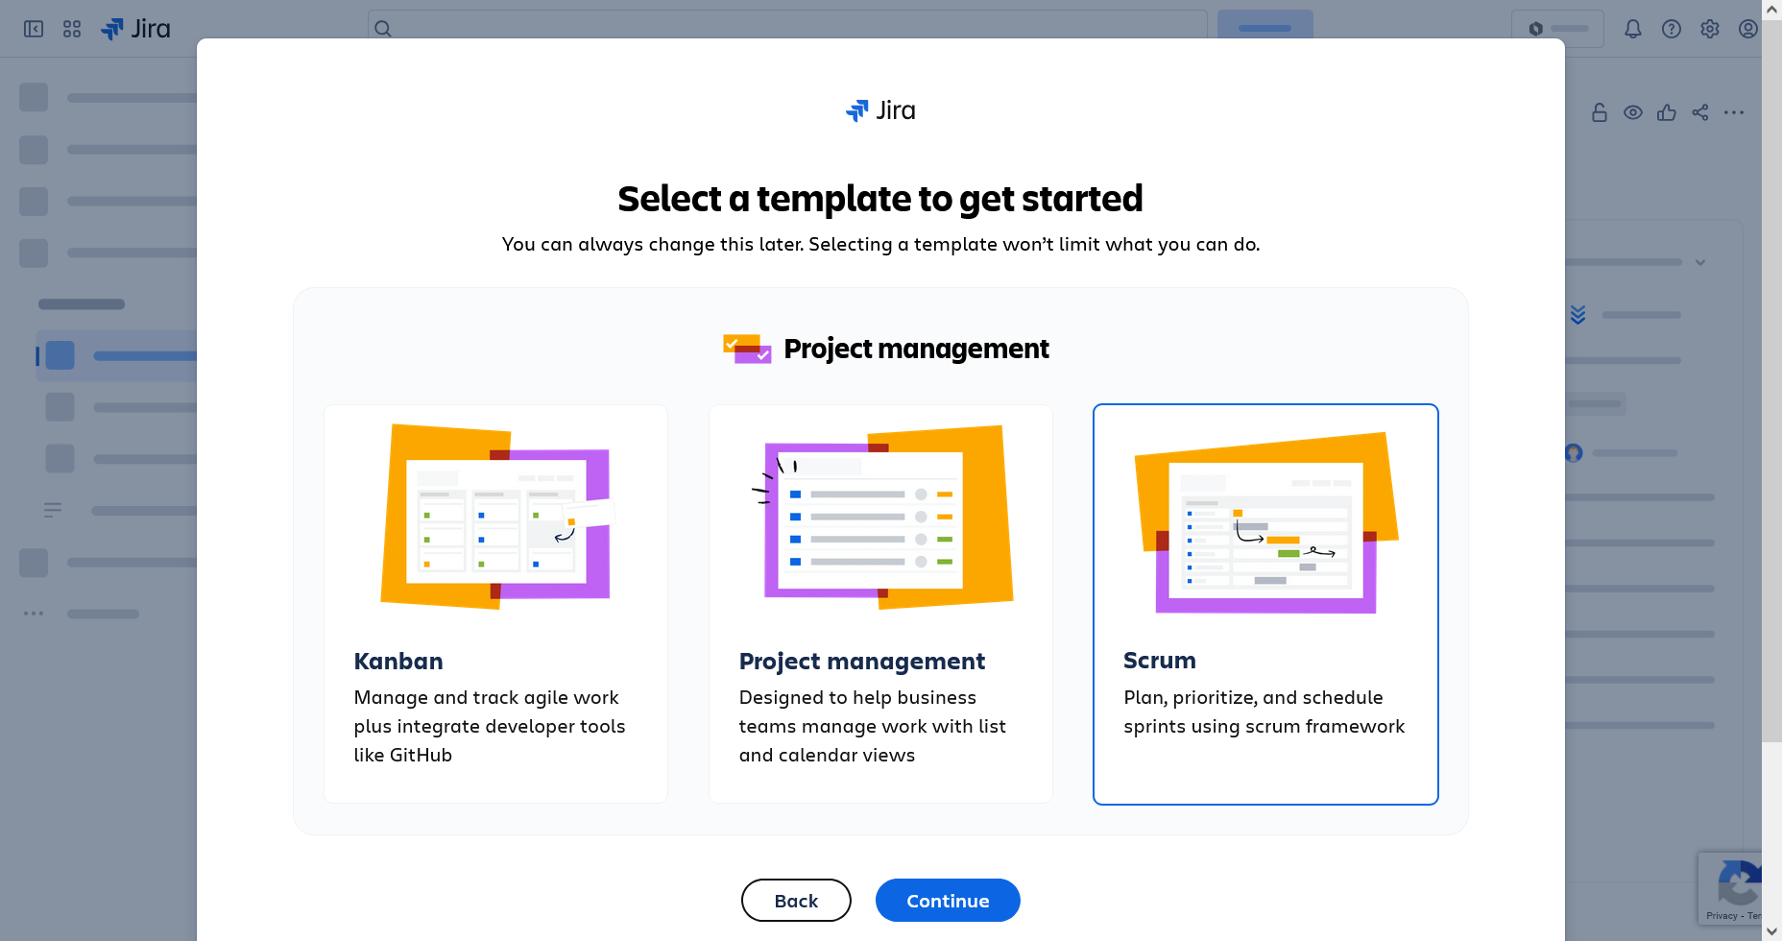

Choosing ‘Scrum ‘Template

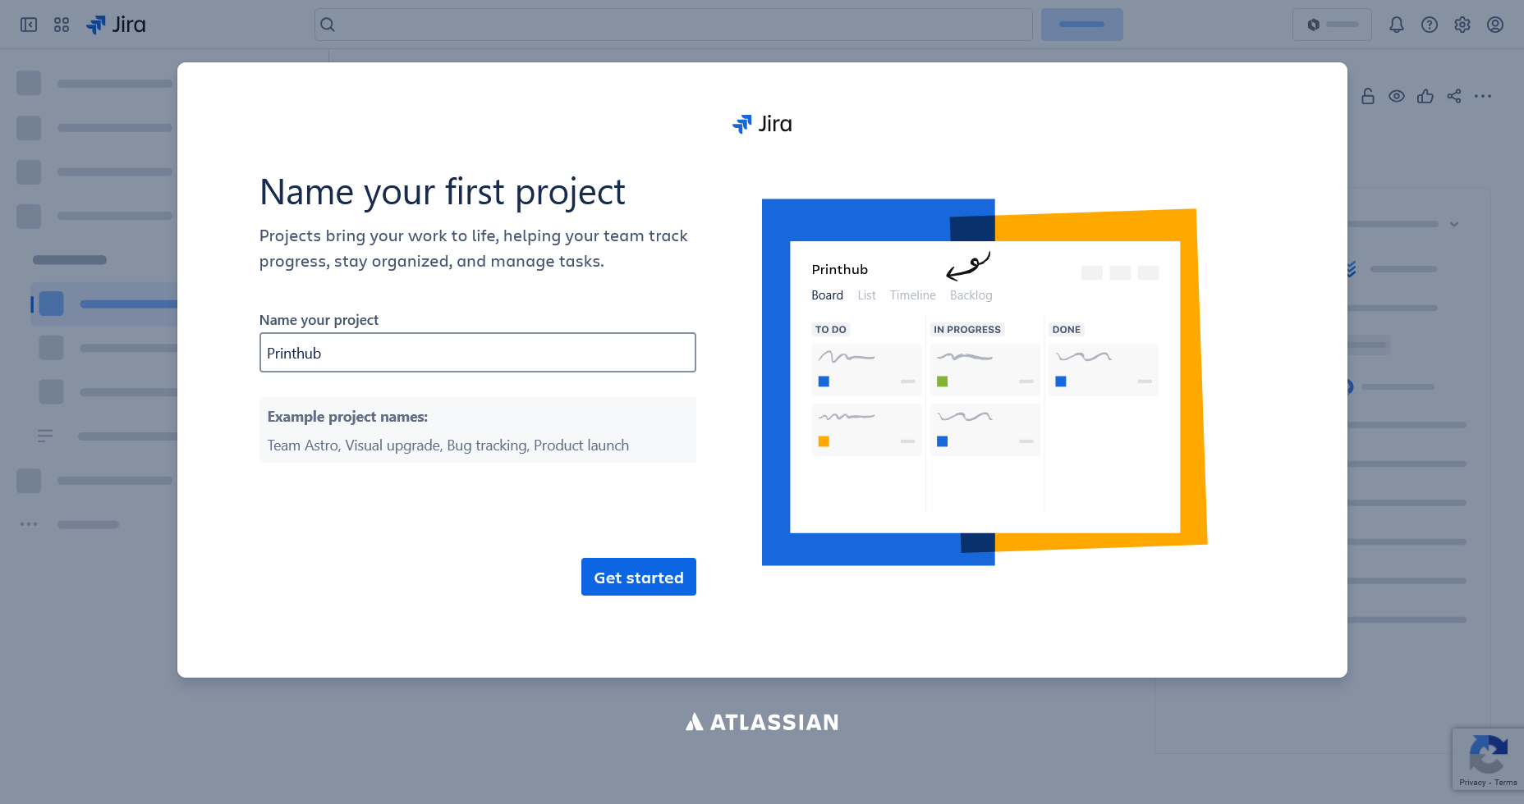

Setting up the Project name

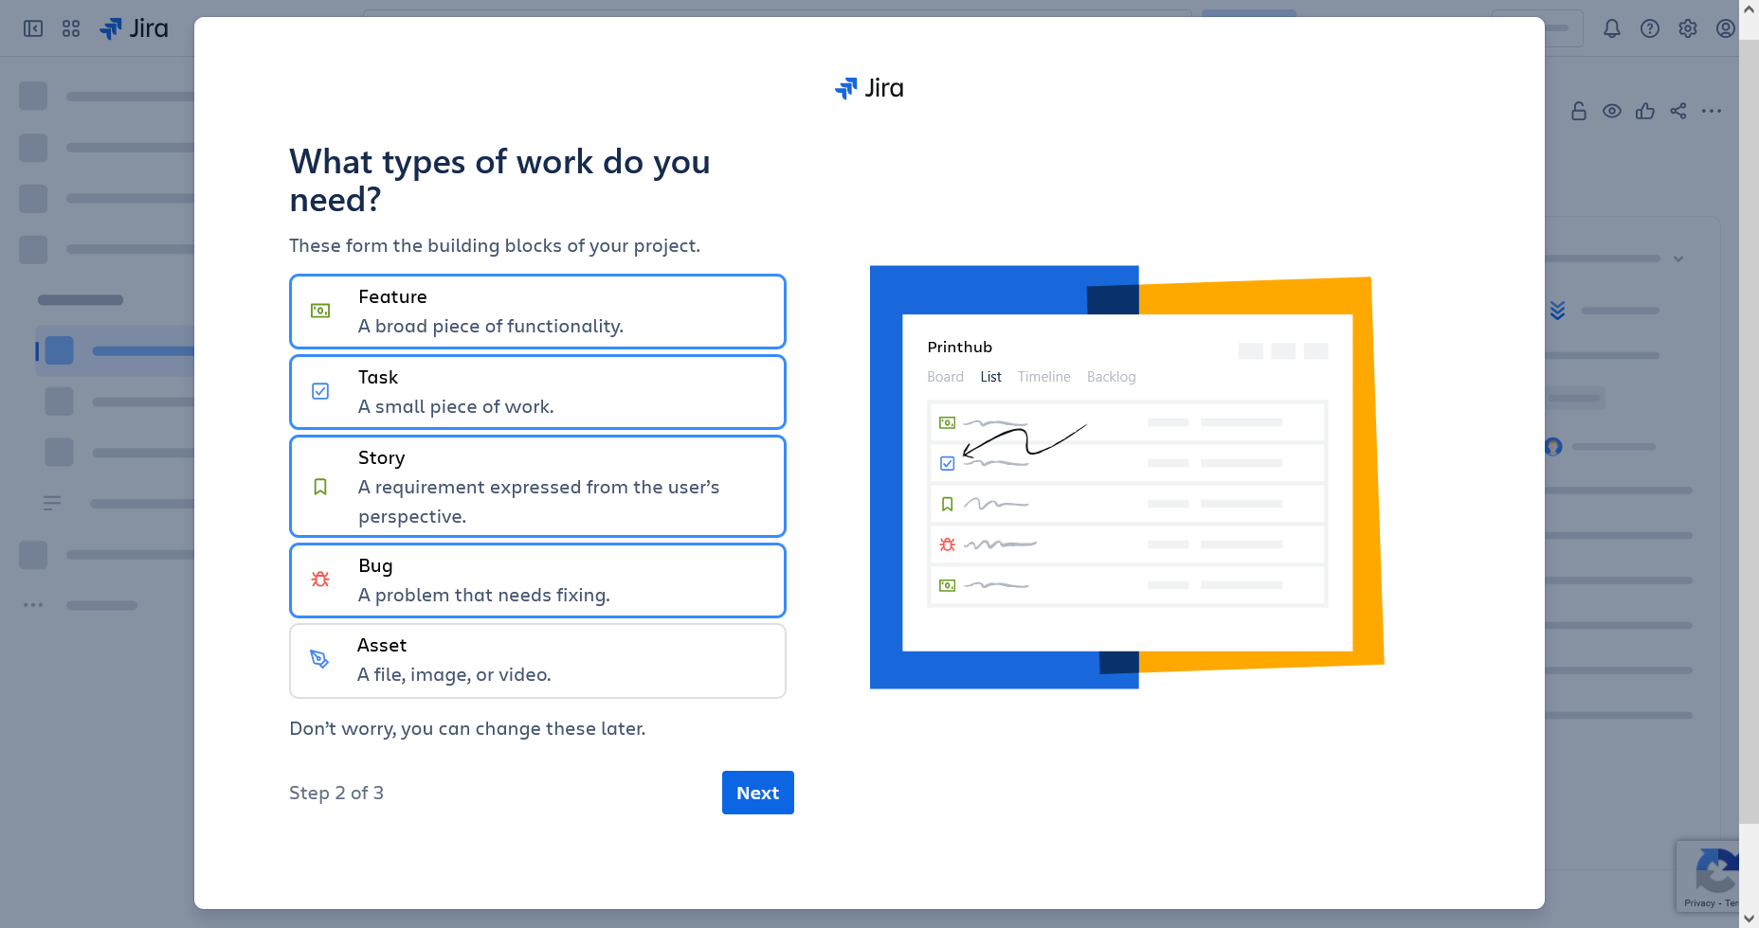

Setting up project types and needs

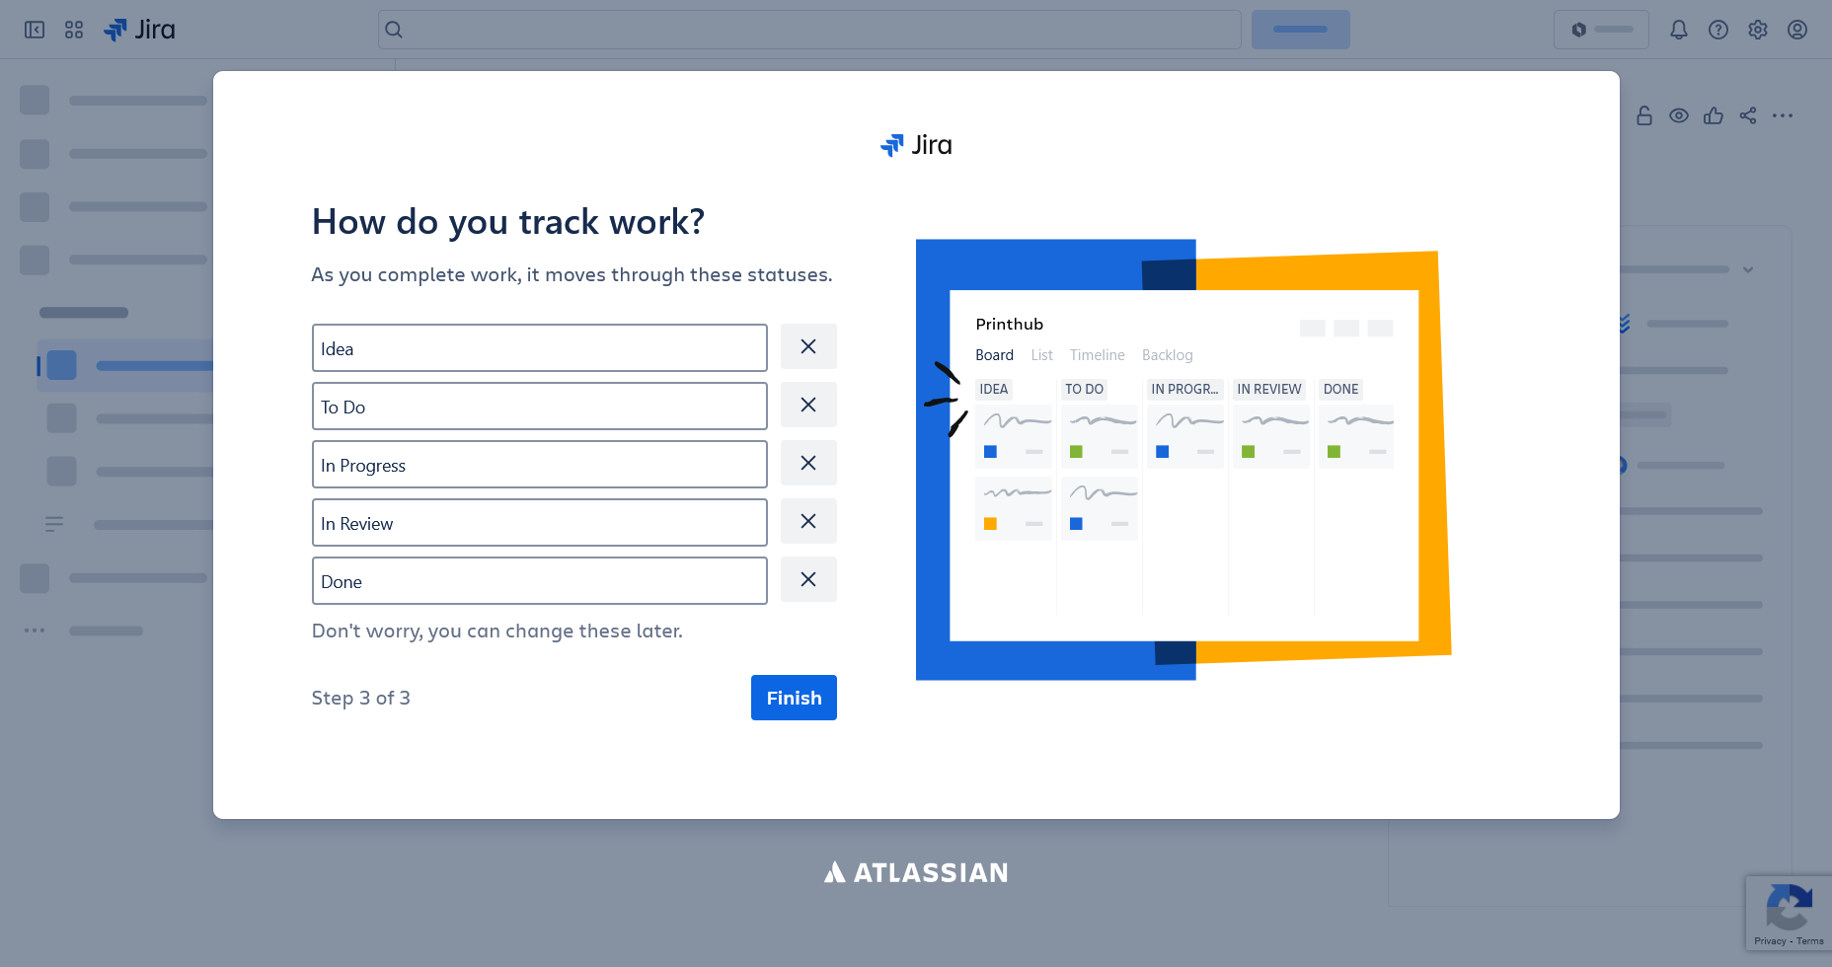

Setting up Project Tracking

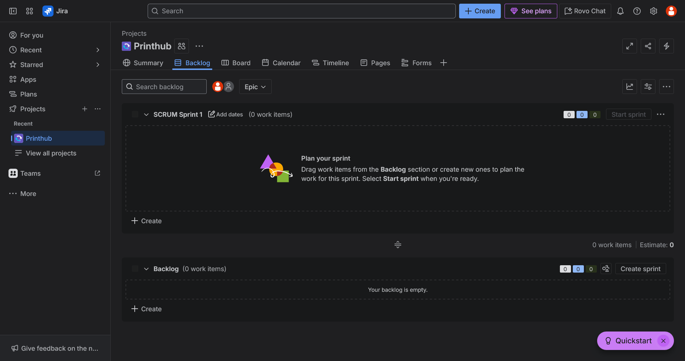

Project ‘Printhub’Dashboard

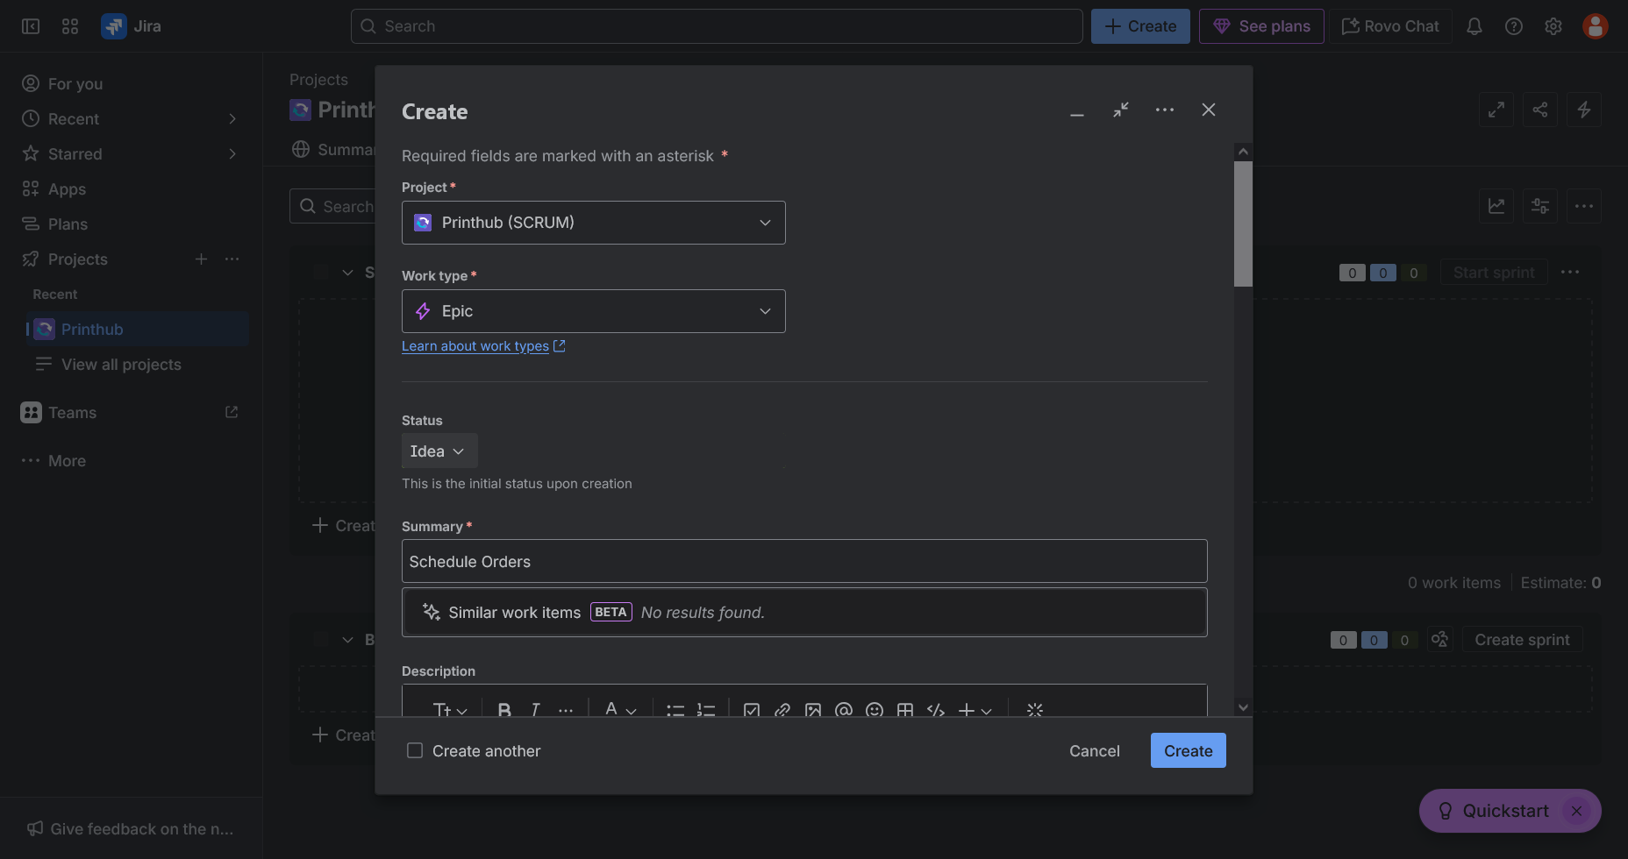

Creating a SCRUM Sprint Cycle

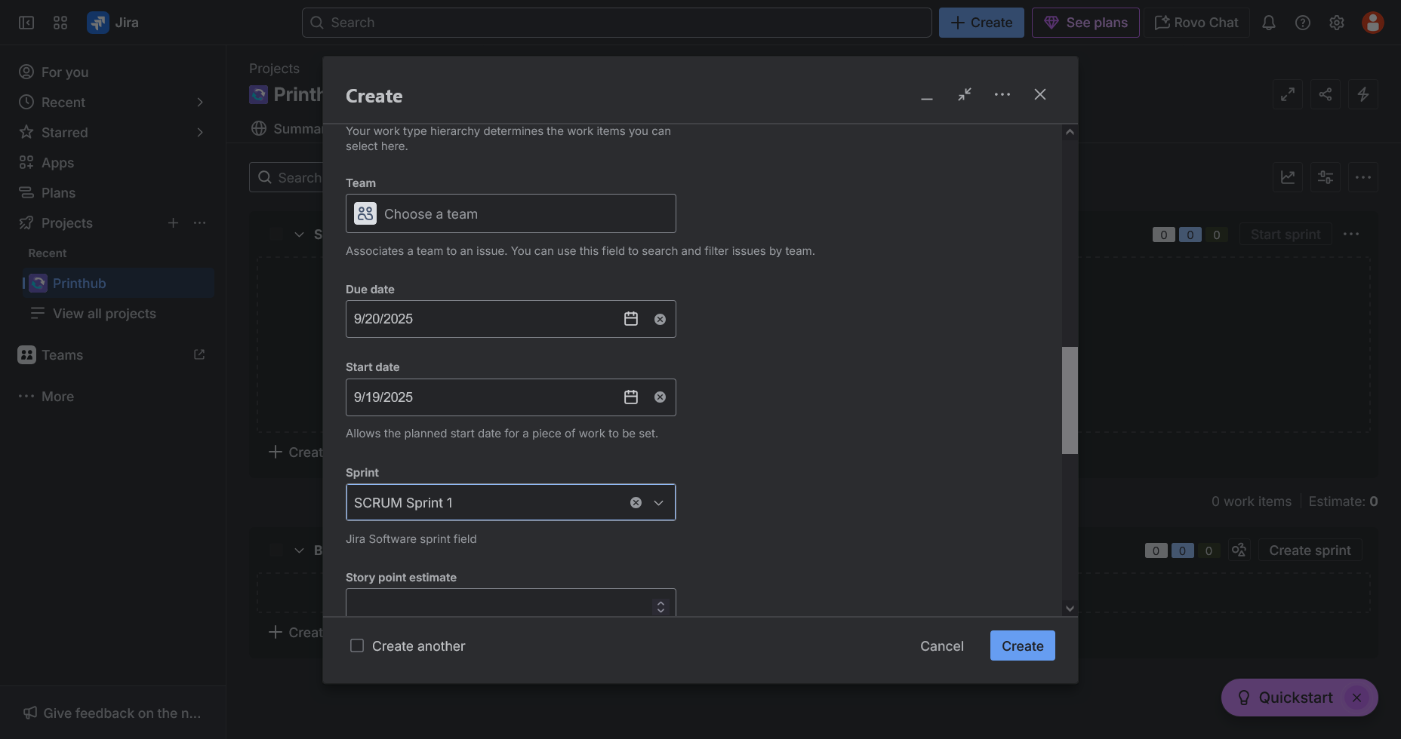

Configuring the SCRUM Sprint Cycle

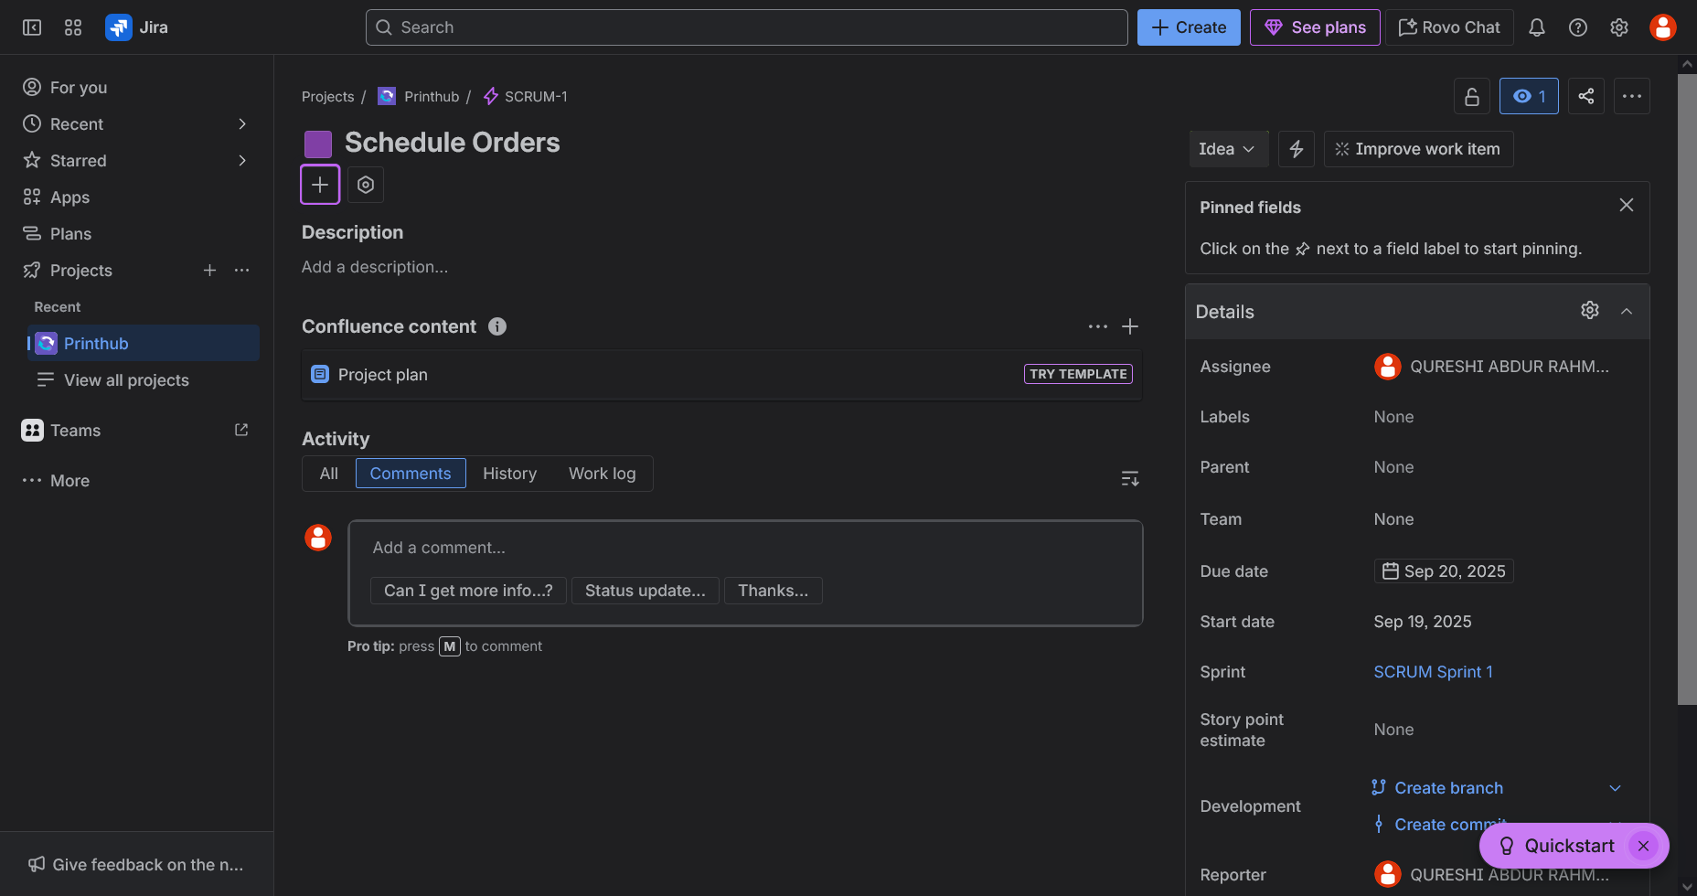

SCRUM Setup completed

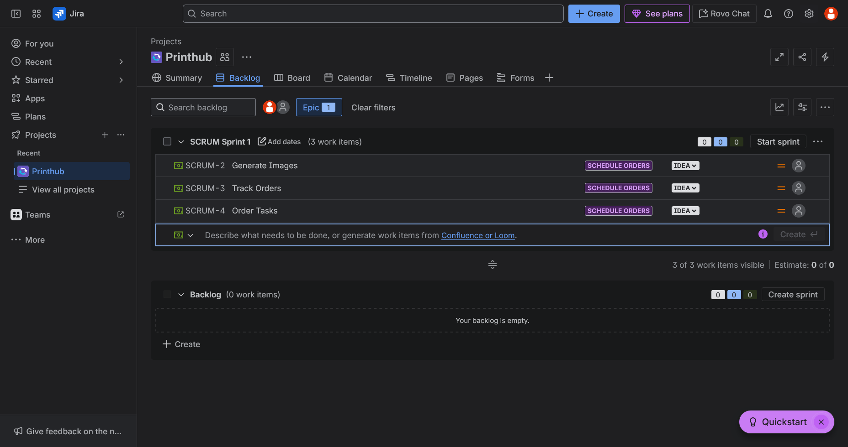

3 Features created

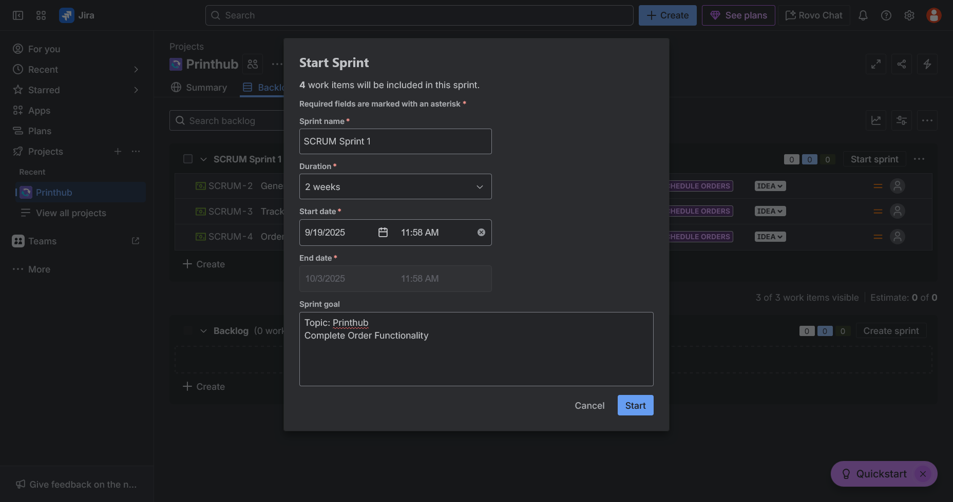

Starting the Sprint

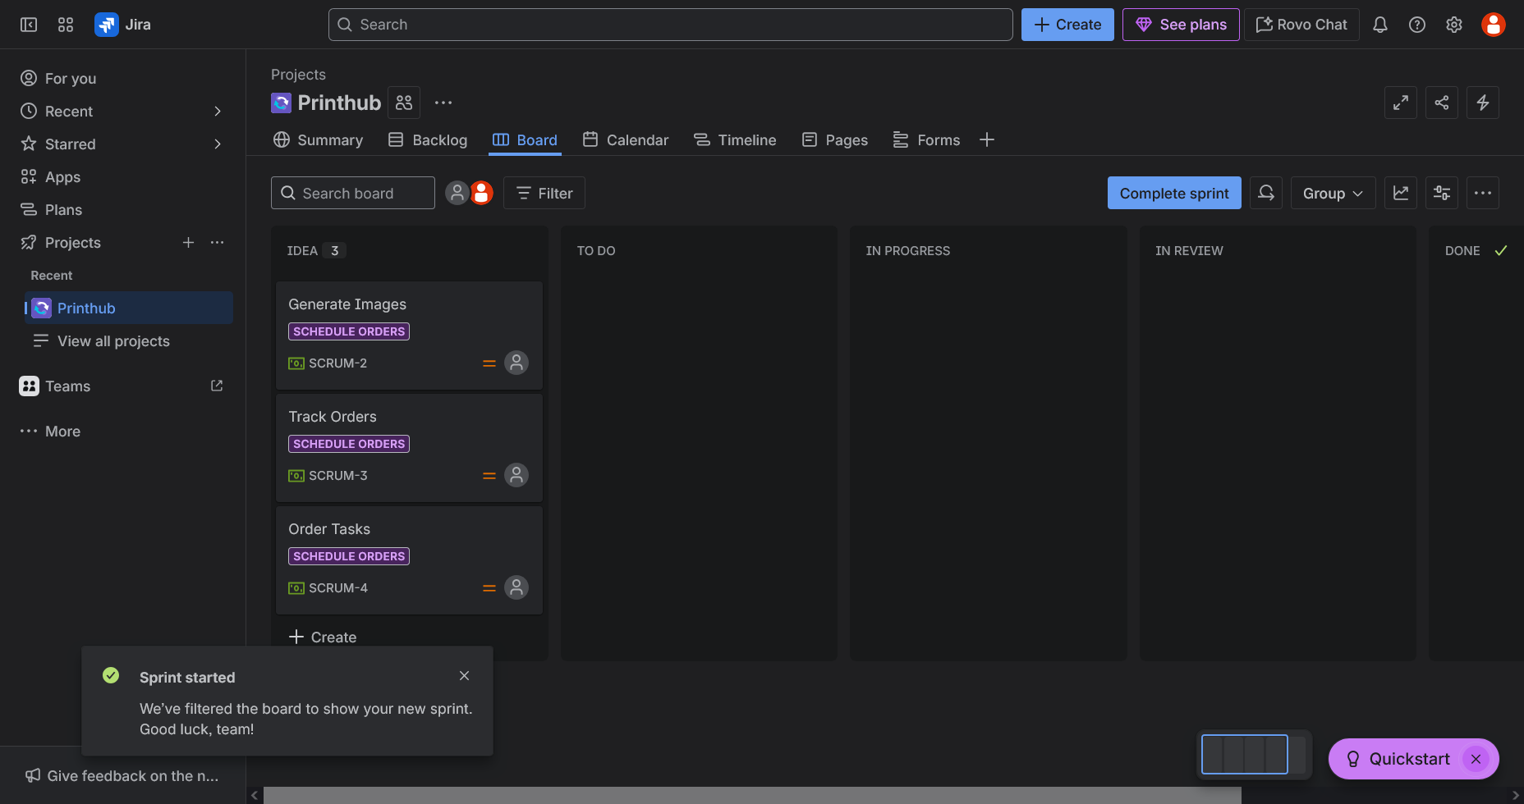

Status after creating the 3 features

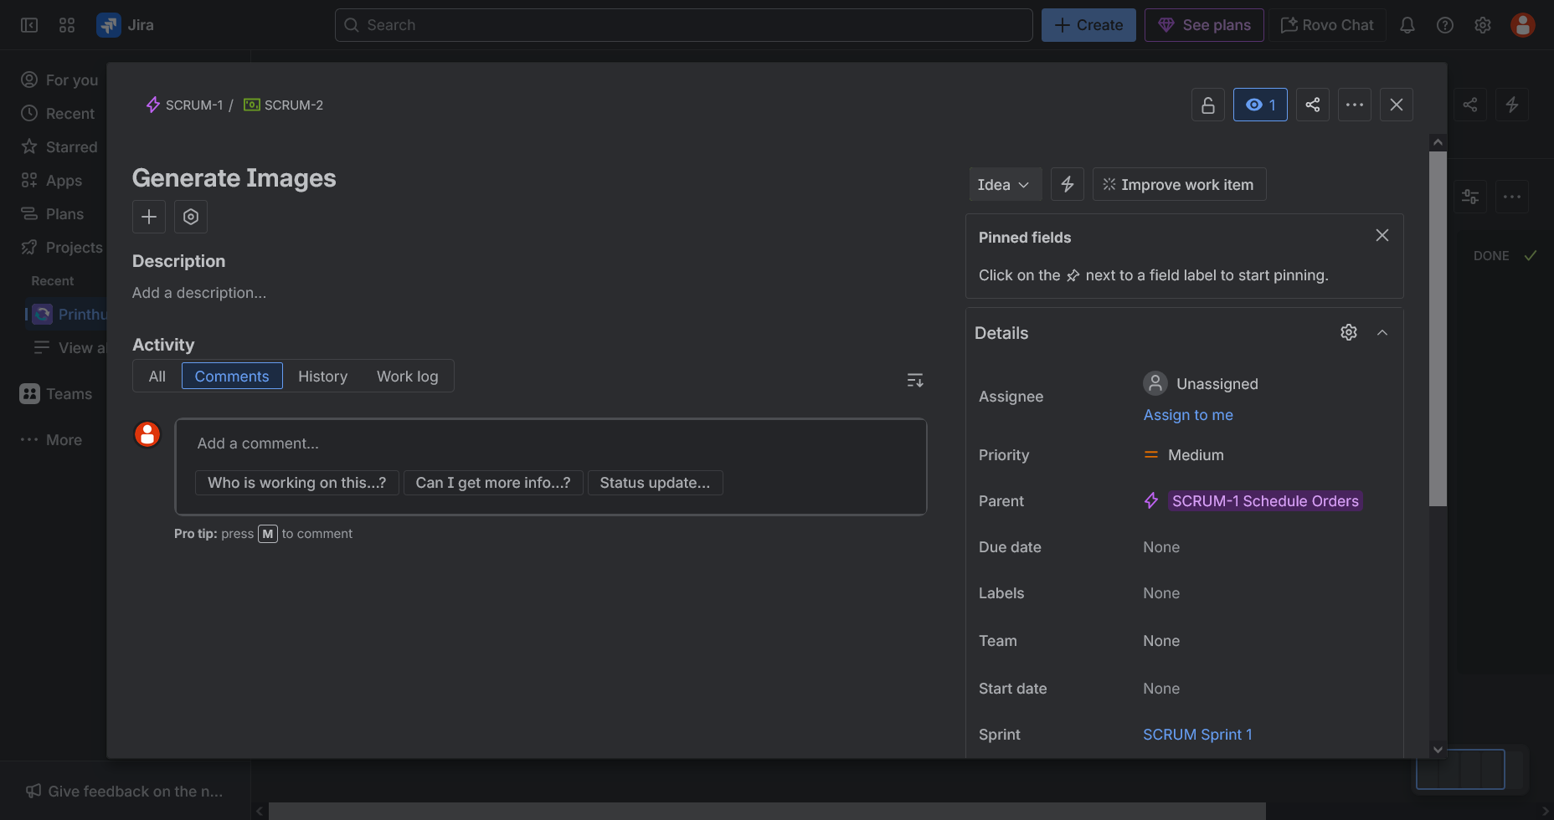

‘Generate Images ‘Details

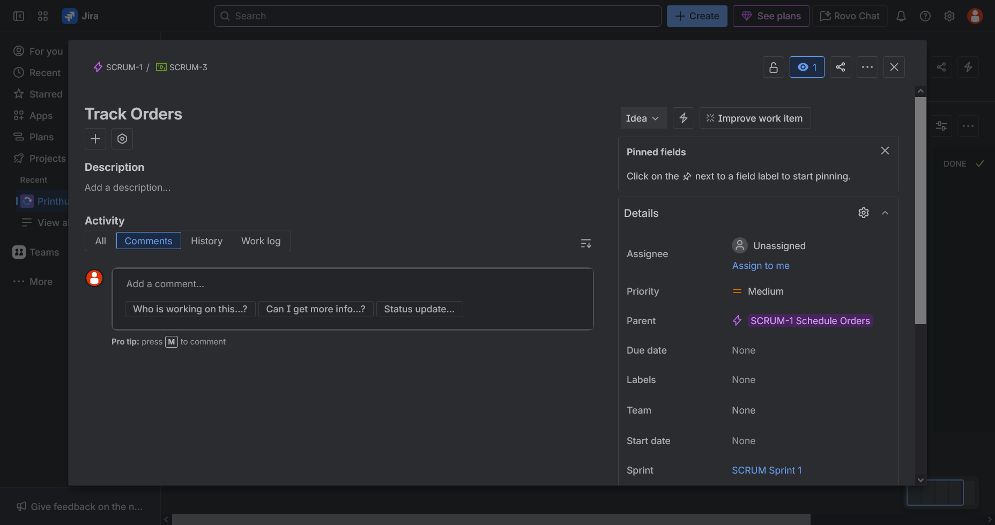

‘Track Orders ‘Details

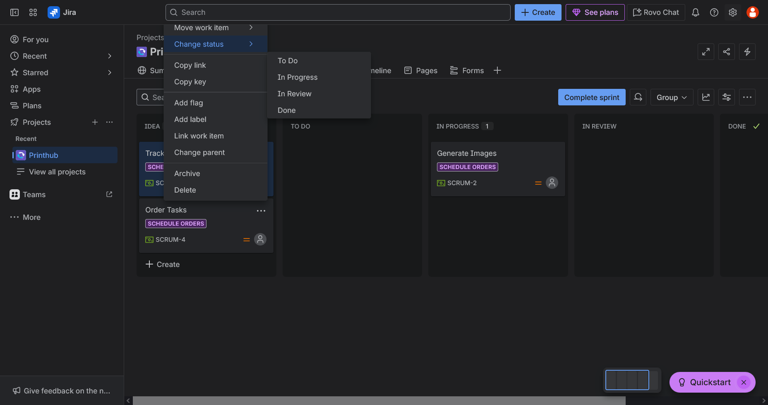

Change status of the feature

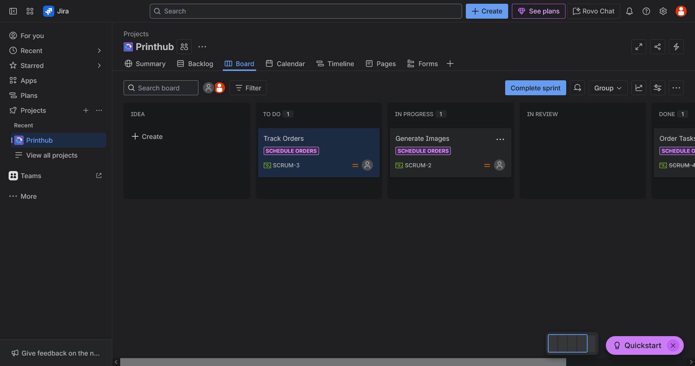

Status after changing status of the features

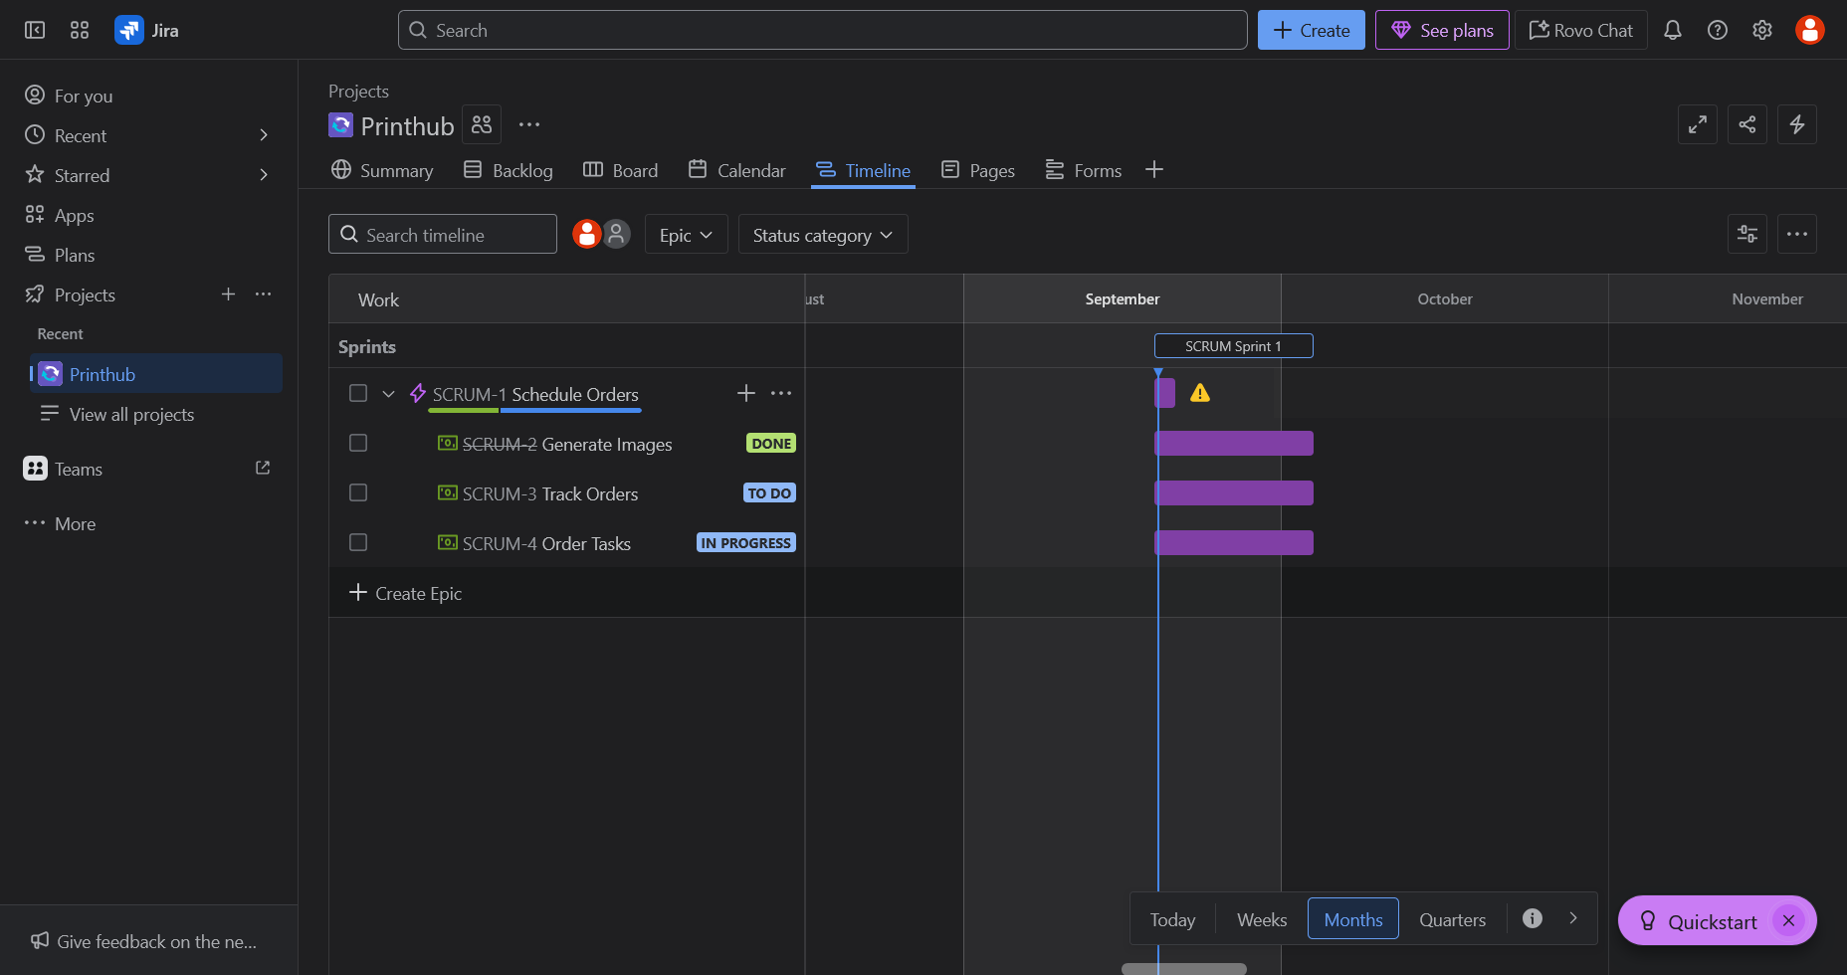

Current Timeline Chart of the Sprint

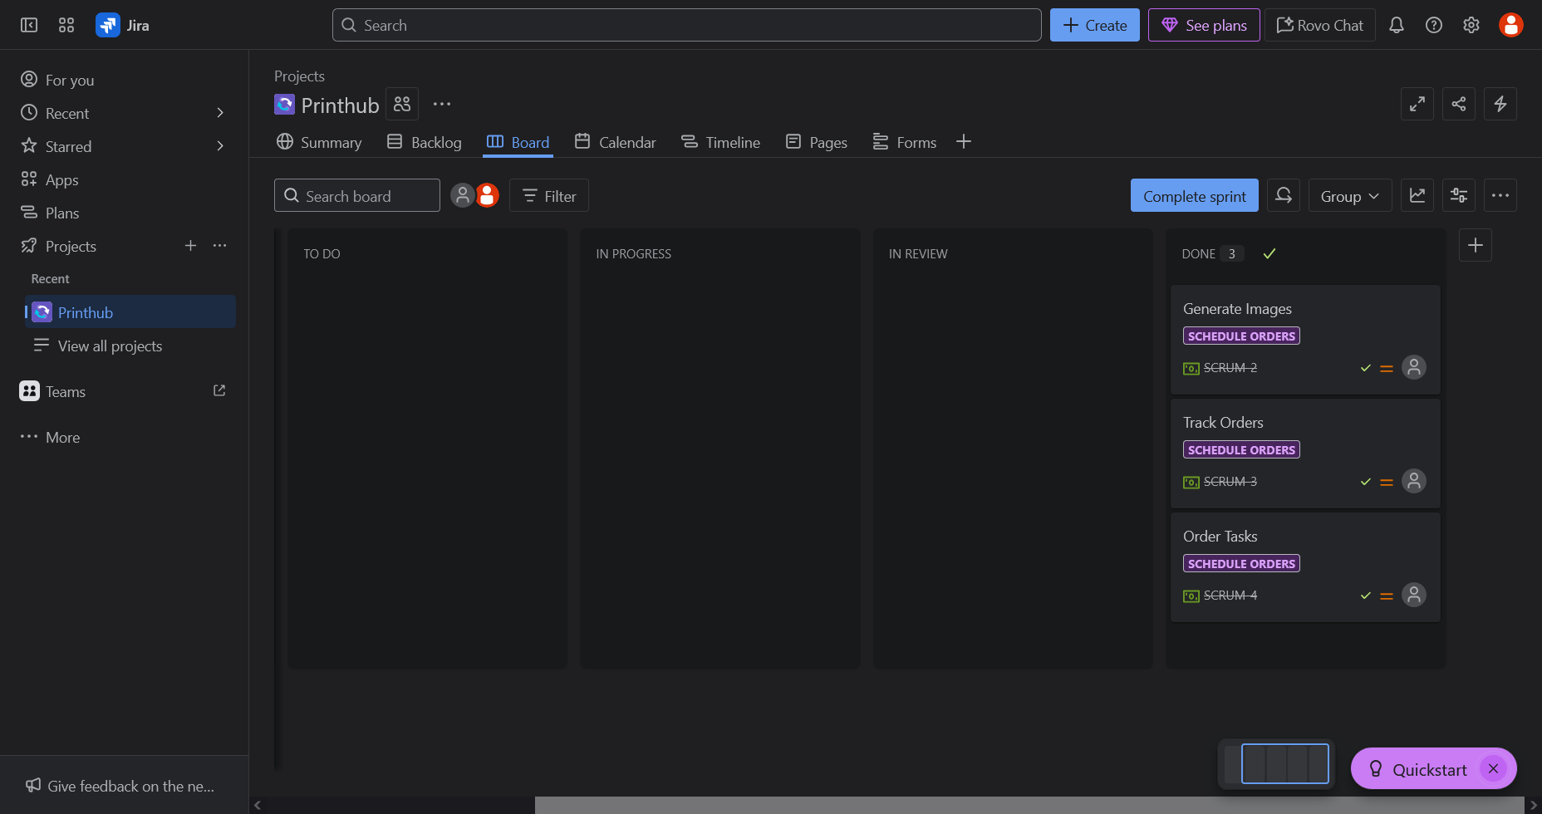

Completed all features

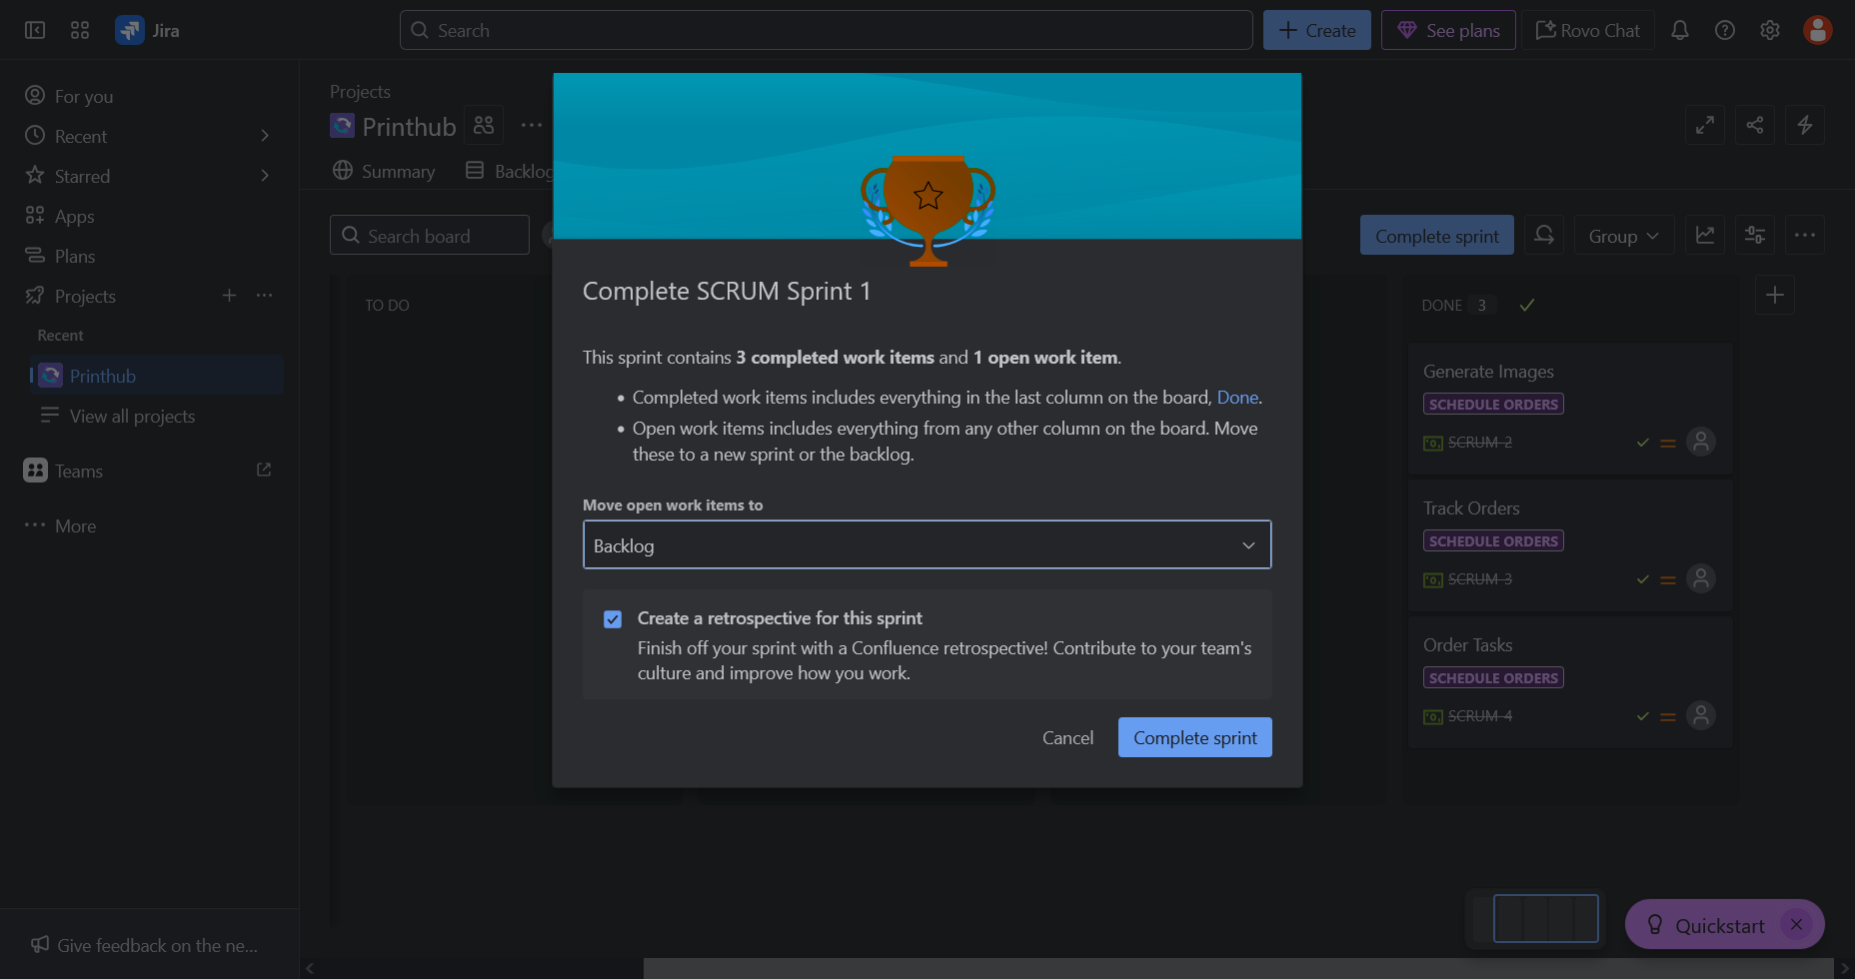

Completing the Sprint

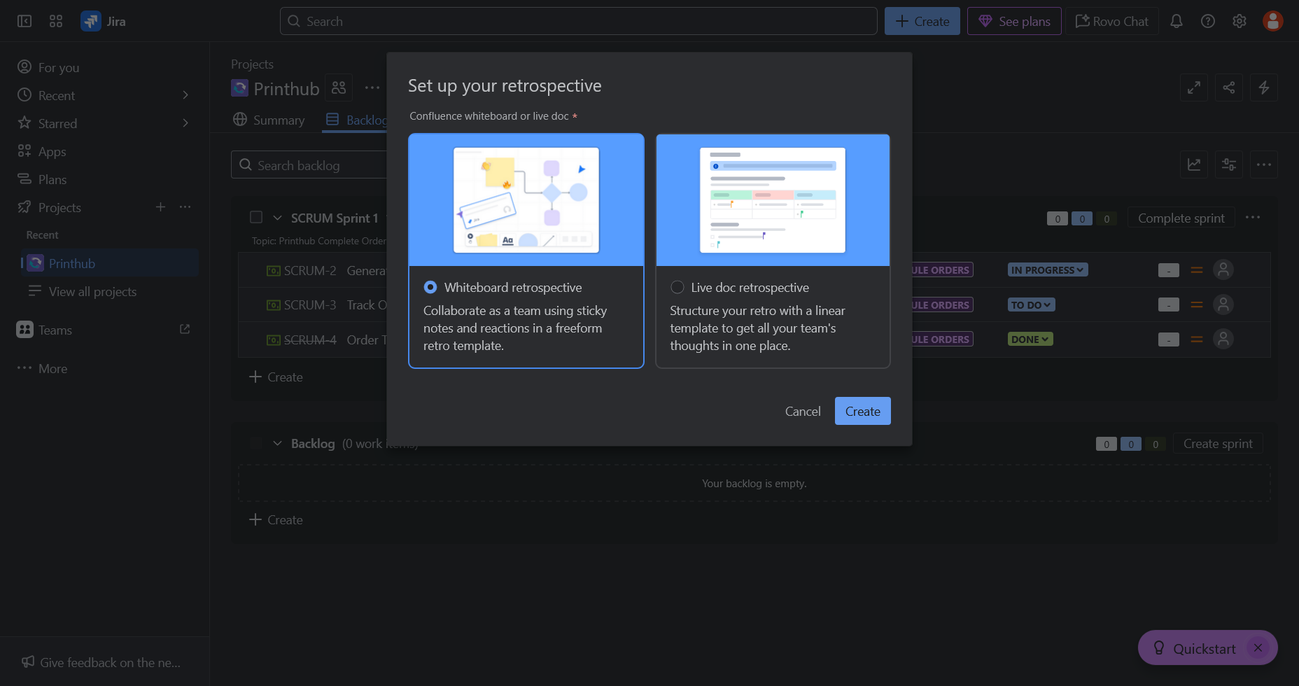

Configuring Completion

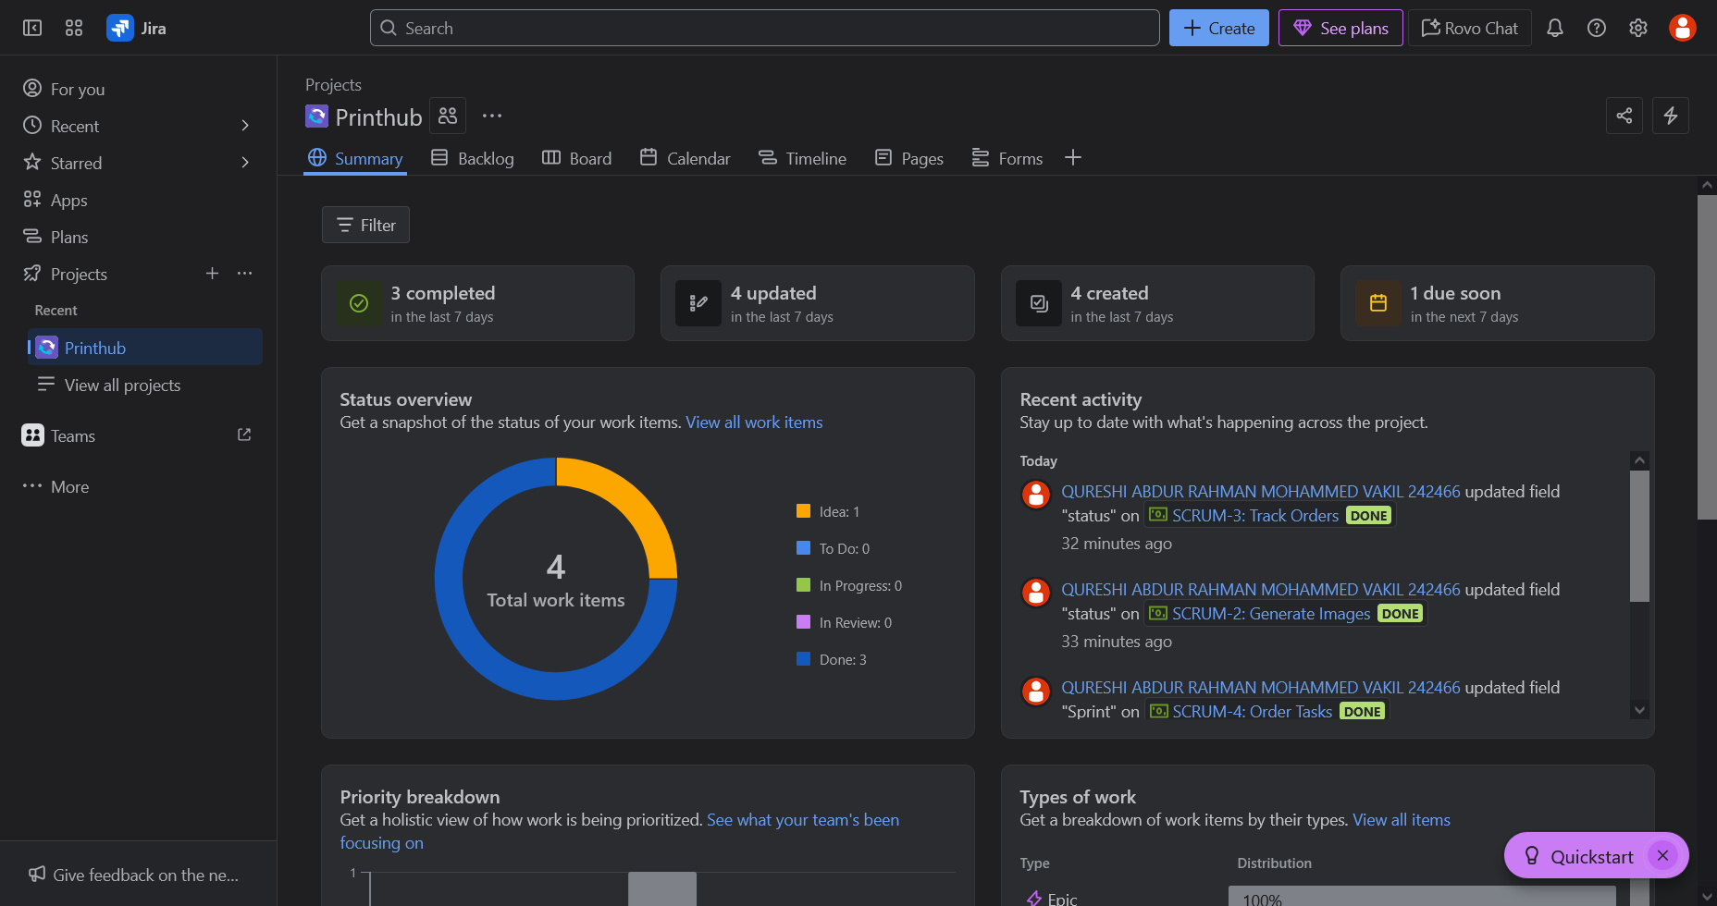 Summary after Sprint Completion

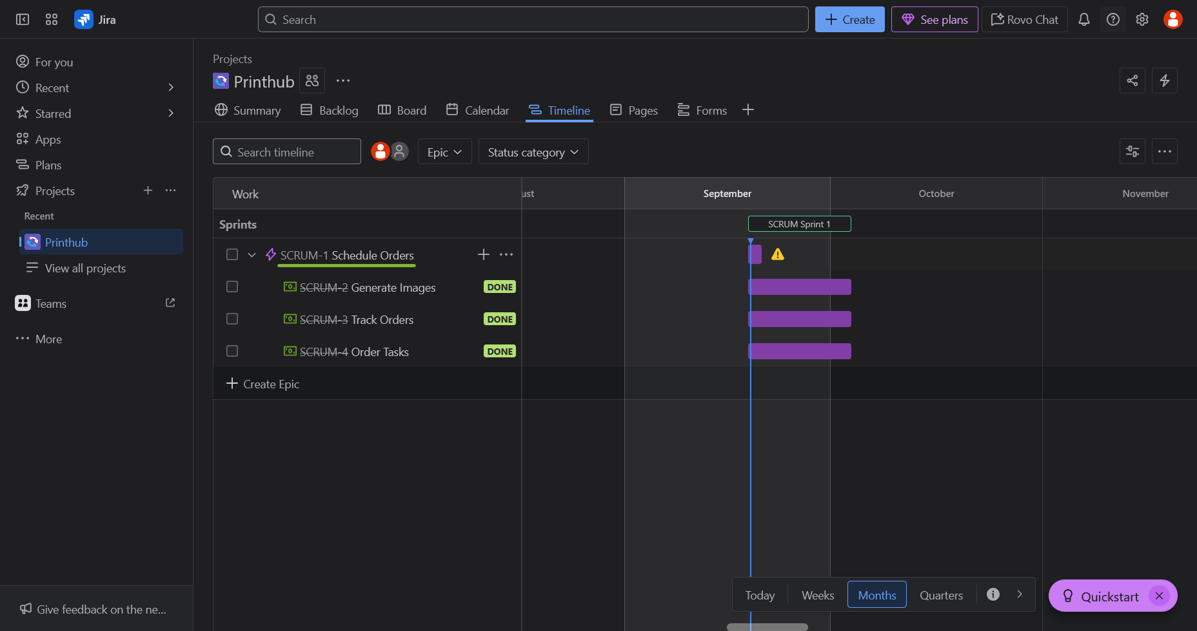

Timeline chart after completion of the sprint